**LAB-2 Assignment**

**1)Program for finding the number contains factors or not**

**Algorithm:** As in the question it is said to find whether the number has factors or not. So, first we are taking array to store values and we read the values given by user. Then user will pick a number from the list, so we take a ‘for’ loop to find out whether the number is in list or not. If it is in the list so we calculate factors using ‘for’ loop by taking i from 2 to n/2 to check it has factors or not . If there are factors for the number by using if-else statement, we will print if it has factors or not.

**Logic:**

#include <stdio.h>

int main()

{

int a[100],i,n,p,flag=0;

printf("Enter total number of wooden pieces:\n");

scanf("%d",&n);

printf("Enter the numbers on wooden piece:");

for(i=0;i<n;i++)

{

scanf("%d",&a[i]);

}

printf("Pick a Number from above:\n");

scanf("%d",&p);

for(i=0;i<n;i++)

{

if(p==a[i])

flag=1;

else

flag=0;

}

if(flag=1)

{

printf("Your number is %d\n",p);

for(i=2;i<=n/2;i++)

{

if(p%i==0)

printf("%d has factors other than 1 and itself\n");

else

printf("%d has only two factors 1 and itself\n");

}

}

else

printf("Select the number from above list\n");

}

**Output:**

**2)Finding Average marks using pointers**

**Algorithm:** We will read the values given by the user using for loop and fix a variable for pointer. At first we are assigning address of a[0] to pointer and using for loop we will array elements using pointer and we will increment it so we can access the other element address and add them to get the total sum. After that we find average to get the average marks of courses

**Logic:**

#include<stdio.h>

int main()

{

int a[100],i,n,sum=0;

int *ptr;

float avg;

printf("Enter total number of courses:\n");

scanf("%d",&n);

printf("Enter the marks of courses:");

for(i=0;i<n;i++)

{

scanf("%d",&a[i]);

}

ptr=&a[0];

for(i=0;i<n;i++)

{

sum=sum+*ptr;

ptr++;

}

avg=sum/n;

printf("The average marks of courses is %f",avg);

}

**Output:**

**3)Program for Swapping numbers from one variable to another using pointers**

**Algorithm:**There are two books so we take two variables and two pointers to store the address values of two variables. We are taking a variable called temp to store the value of b. Now we assign pointer a value to pointer of b and temp value to pointer of a. We are doing it in pointers so it will just change the addresses of two variables.

**Logic:**

#include<stdio.h>

int main()

{

int a,b,temp;

int *ptr1,*ptr2;

printf("Enter the Jersey numbers from two notebook:");

scanf("%d %d",&a,&b);

ptr1=&a;

ptr2=&b;

printf("The jersey number before swapping books:%d,%d\n",a,b);

temp=*ptr2;

*ptr2=*ptr1;

*ptr1=temp;

printf("The jersey number after swapping books:%d,%d",a,b);

}

**Output:**

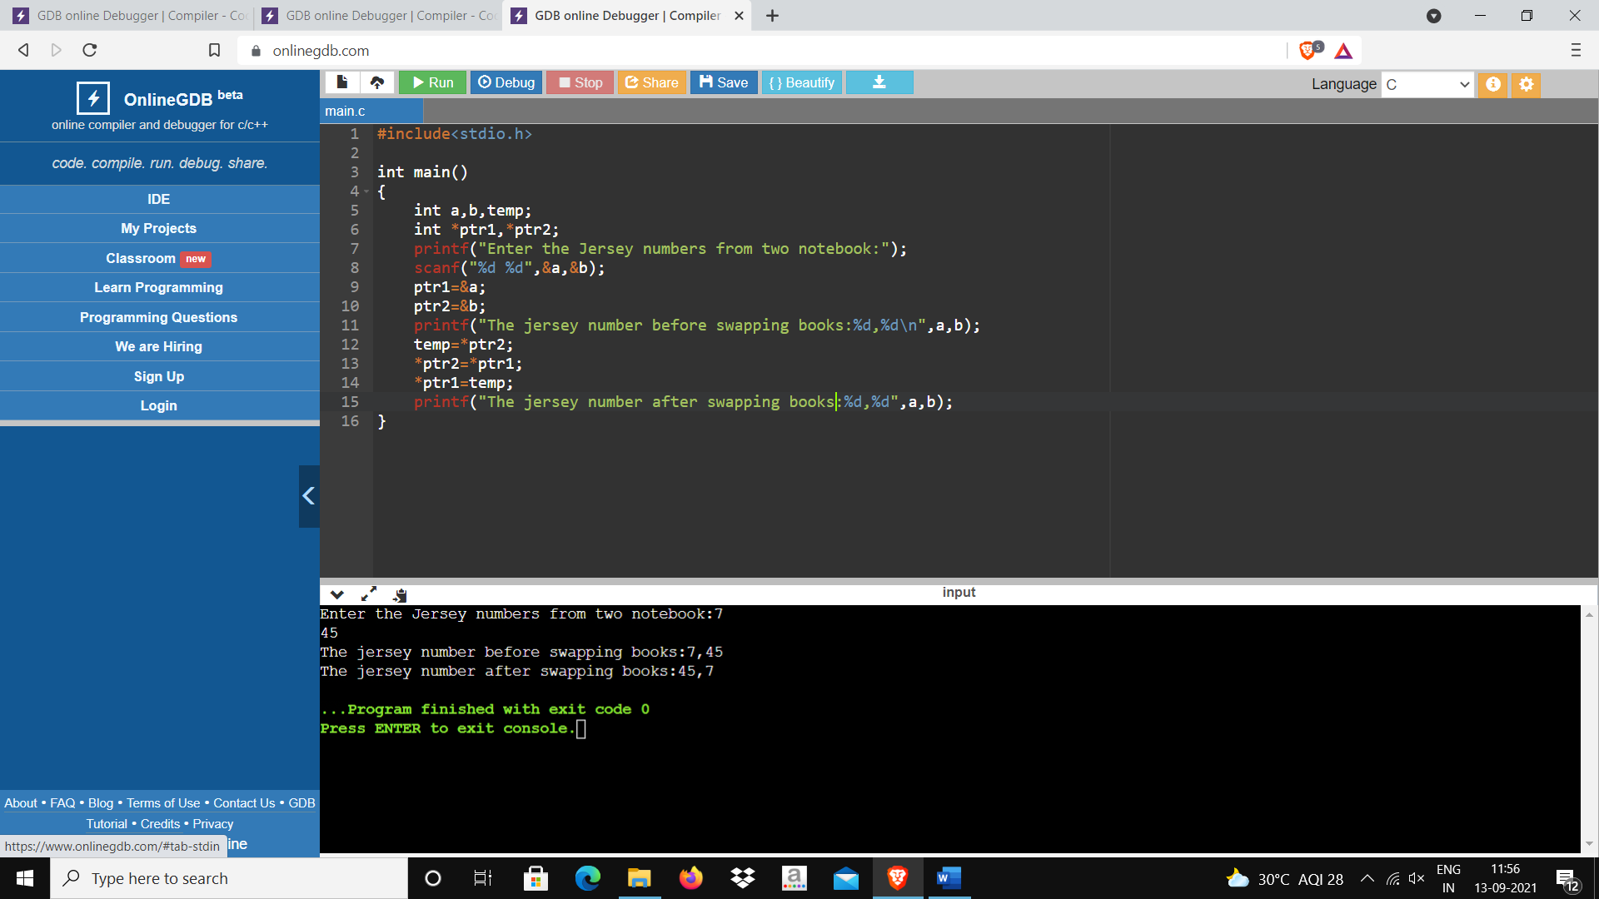

**Time of Submission:** 4:00pm 13/9/21

**Submitted by:** Gelle Hruthesh Reddy